|  |
| --- |
| Silensomes™ :  Description and user guide |

Résultat de recherche d'images pour "biopredic"Among other tests, the Silensomes™ can be used for cytochrome P450 screening and phenotyping assays, to identify enzymes responsible for metabolizing drug candidates.

1. **Introduction**

In vitro identification and measurement of the contribution of the major cytochrome P450 enzymes (CYP450s) involved in the metabolism of a new drug candidate, also called “CYP450 phenotyping”, helps to predict the impact of other co-administered drugs (perpetrators) on the pharmacokinetics of the new chemical entity (NCE = victim). Today, a battery of in vitro tests (recommended by the regulatory agencies) is required for CYP450 phenotyping, each of which has a number of limitations.

A new in vitro model, called Silensomes™, has been developed to address the disadvantages of the current methodologies. Silensomes™ are human pooled HLM chemically and irreversibly inactivated for one specific CYP450 activity (1A2, 2A6, 2B6, 2C8, 2C9, 2C19, 2D6, 2E1, 3A4) using a mechanism based inhibitor (MBI). SilensomesTM and Control SilensomesTM are handled in the same manner as conventional HLM and are ready-to-use for phenotyping assays. Each CYP- Silensomes™ batch exhibits a high specificity and extent of their targeted CYP inhibition (>80 %),

The Control SilensomesTM, which is produced under the same conditions as Silensomes™ but without MBI.

Silensomes™ can be handled in the same way as conventional HLMs and are specifically developed for phenotyping assays and contribution evaluation (fm) of each CYP involved in the metabolism of test compounds. These unique microsomes represent a powerful tool for drug development and ensure an accurate prediction of CYP450-mediated drug metabolism and the risk of pharmacokinetic drug-drug interactions.

An example of the specificity and potency of silencing is shown in Figure 1 for CYP3A4-Silensomes™ and its associated control. Azamulin caused >80% inhibition of CYP3A4 mediated metabolism of nifedipine, midazolam and testosterone but had no impact on the other CYP450 activities tested. The remaining activity in nifedipine and midazolam incubations is due to CYP3A5, which can be inhibited with ketoconazole.

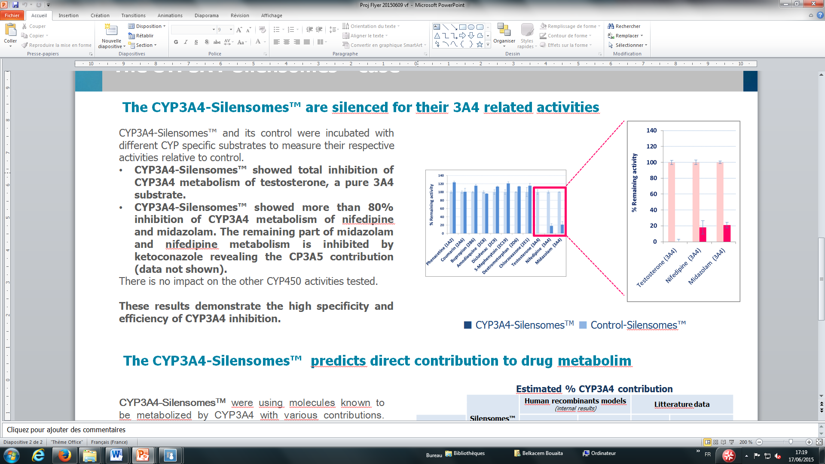

***Figure 1. Specificity and potency of CYP3A4 inhibition in CYP3A4-Silensomes.***

1. **Contents**

In one kit contains:

* One vial of CYP-Silensomes™ with one specific CYP activity inactivated, according to the table below.
* One vial of the Control Silensomes™

|  |  |  |  |  |
| --- | --- | --- | --- | --- |
| Product | Size  µL | Protein  mg.mL-1 | Protein per vial  mg | CAT. # |
| Human Liver CYP1A2-Silensomes™ | 150 | 20 | 3 | SIL210 |
| Human Liver CYP2A6-Silensomes™ | 150 | 20 | 3 | SIL220 |
| Human Liver CYP2B6-Silensomes™ | 150 | 20 | 3 | SIL230 |
| Human Liver CYP2C8-Silensomes™ | 150 | 20 | 3 | SIL250 |
| Human Liver CYP2C9-Silensomes™ | 150 | 20 | 3 | SIL260 |
| Human Liver CYP2C19-Silensomes™ | 150 | 20 | 3 | SIL270 |
| Human Liver CYP2D6-Silensomes™ | 150 | 20 | 3 | SIL240 |
| Human Liver CYP3A4-Silensomes™ | 150 | 20 | 3 | SIL200 |
| Human Liver Control Silensomes™ | 150 | 20 | 3 | SIL000 |

The number of reaction incubations that can be conducted with one vial of CYP-Silensomes will depend on the protein concentration selected. Examples of different protein concentrations and sample numbers for phenotyping assays depend on the rate of metabolism:

|  |  |  |
| --- | --- | --- |
| Expected rate of metabolism (fast medium, slow) | The chosen protein concentration for assay (mg.mL-1) | Number of samples  per vial |
| Fast | 0.3 | 100 (2.5 mL, 50 L/sample) |
| Medium | 1 | 30 (2.5 mL, 50 L/sample) |
| Slow | 2 | 15 (1.25 mL, 50 L/sample |

If the rate of the metabolism, the incubation time and protein concentration linearities are not known for the NCE, The linearity tests can be realized on HLM and the optimum conditions chosen for the assays .

1. **Caution**

In all human hepatic tissues used for Silensomes™ production, the serological screening is negative for hepatitis B, hepatitis C and HIV viruses.

Although controls have been performed, human-derived material should be considered as a potential biohazard. Accordingly, take maximum care in order to protect yourself and your colleagues when handling, storing or discarding this product.

The Silensomes™ are for *in vitro* research only.

1. **Storage and thaw-refreeze Conditions**

The Silensomes™ and Control Silensomes™ should be stored at -70°C.

CYP450 enzymatic activities in Silensomes™ and associated controls are stable for up to 5 years when stored at -70°C.

The Silensomes™ and Control Silensomes™ can be freeze-thawed up to 10 times without loss of CYP450 activities. After thawing Silensomes™, the remaining samples should be kept on ice and be frozen as quickly as possible and stored at -70°C.

1. **Additional reagents required but not supplied**

|  |  |
| --- | --- |
| Buffer: | TRIS-HCl or phosphate buffer pH 7.4 supplement with MgCl2 |
| Cofactor: | NADPH |

1. **Experimental assays with Silensomes™**

The protocols described below are provided only as a guide. Silensomes™can be used in variety of incubation conditions, according to the compound being tested.

**Introduction**

This section describes how SilensomesTM can be used to evaluate the intrinsic clearance (Clint) of a test compound, allowing an accurate prediction of the *in vivo* contribution of CYPs (fm). The fm is easy to calculate, according to the following equation:



(Equation 1)

The *in vitro* intrinsic clearance (Clint, mL/min.g protein) can be determined by measuring the substrate depletion (representing total metabolites), using the following equation:

${Cl}_{int}= \frac{Slope× Vol }{prot}$ (Equation 2)

Where the “slope” is the elimination rate constant (min-1) for exponential substrate loss, “Vol” is the incubation volume (mL) and “prot” is the microsomal protein (grams) in the incubation.

Clearance is based on the test compound disappearance when the study is performed at early stage of drug development (this is an advantage when the metabolites are unknown or when authentic metabolite standards are unavailable) but ideally, later in development, metabolite formation can also be evaluated.

**Incubation conditions with CYP-Silensomes™**

The incubation conditions with Silensomes™ must be in the linear portion of the graph, *i.e.,* metabolite formation is directly proportional to time and protein concentration.

It is recommended to use TRIS-HCl or phosphate buffer pH 7.4 supplement with MgCl2 and NADPH as co-factor

We suggest 2 experimental approaches to incubate a test compound with Silensomes™ and Control-Silensomes™ :

**Case ➀: six incubation times**

Incubation times: 0, 10, 20, 30, 40 and 45 minutes

Replicates: n=1 well for all assays

Incubation volume: 450 µL

Microsomal concentration: 1 mg.mL-1 or optimal concentration based on linearity on HLM

**Case ②: a single incubation time**

Incubation time: one incubation time in the linear portion of depletion profile using HLM

Replicates: n=3 wells for all assays

Incubation volume: 100 µL

Microsomal concentration: 1 mg.mL-1 or an optimal concentration based on linearity on HLM

**Common conditions:**

Buffer: 50 mM TRIS-HCl or 100mM phosphate buffer pH 7.4 supplemented with 5 mM MgCl2

Cofactor: 1 mM NADPH

Temperature: 37°C

Test compound concentration: 1 concentration (for example 0.1 to 1 µM) based on the limit of solubility in the experimental conditions and below the expected Km value. Ideally, a pharmacologically relevant concentration of the test compound is tested.

Controls: Parallel incubations with Control Silensomes™ must be incubated to determine the involvement of each CYP in the metabolism of the test compound (see graph in section entitled “Data treatment”).

Intermediate solvent: If the test compound needs to be dissolved in an intermediate solvent, care must be taken with respect to the type (e.g. DMSO) and concentration because some CYP450s are very sensitive to solvents (they are inhibited). Therefore, the lowest concentration of solvent must be added to the incubation medium.

Stop solution: Incubations are stopped by adding an equal volume of a denaturing solution such as organic solvents (methanol, acetonitrile etc) or acids.

**Incubation: general protocol**

Before starting the incubation, the Silensomes™ and the Control-Silensomes™ are thawed and kept on ice to maintain them at ~4°C. Likewise, TRIS-HCl buffer, test compound and the cofactor, NADPH, are also prepared at ~4°C.

Incubations are carried out as follows (n = 1 for the CYP-Silensomes™; n = 1 for the Control-Silensomes™):

Pre-warm of all the components of the incubation separately

at 37°C for 5 min

ê

Combine all components except NADPH in the incubation medium

ê

Add NADPH to the incubation medium  
to start the CYP-catalysed reactions

ê

Incubate at 37°C for 1 or 6 incubation times

according to the protocol chosen (① or ②)

ê

At each incubation time point, remove 50 µL of the incubation medium and combine with 50 µL of stop solution

ê

Store for minimum of 1 h at  *~*4°C   
to allow for proteins to precipitate

ê

Centrifuge at 3500 ×g for 15 min at 4°C  
ê

Analyse supernatants immediately or   
store at -80°C until analysis by HPLC-MS/MS

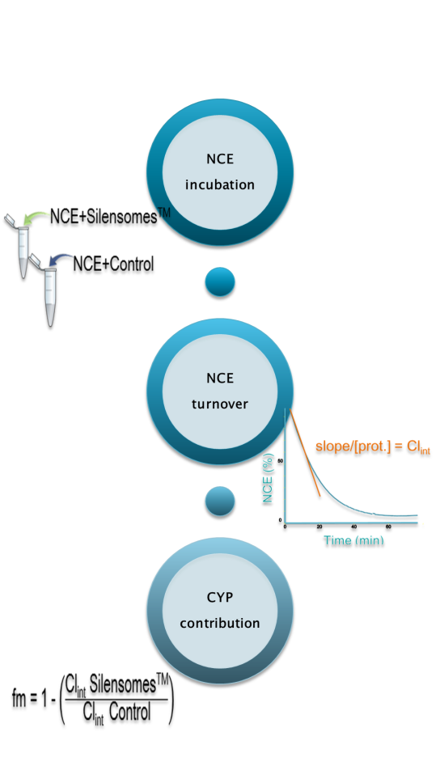**Data handling**

The *in vitro* intrinsic clearance (Clint, mL/min.g protein) is determined according to the following equation:

${Cl}_{int}= \frac{Slope× Vol }{prot}$ (Equation 2)

* Slope is the elimination rate constant (min-1)
* Vol is the incubation volume (mL)
* Prot is the microsomal protein (grams)

For the SilensomesTM approach, the CYP contribution to the metabolism of drug is estimated by calculating the ratio of the intrinsic clearance values in CYP-SilensomesTM (Clint CYP-SiL, mL/min.g protein) and in Control-SilensomesTM (Clint cSiL, mL/min.g protein).



(Equation 1)

The relative contribution of the CYP of interest is estimated using the following equation:

$Contribution=(1-\left(\frac{{Cl}_{int} CYP-SiL)}{{Cl}_{int} cSiL}\right))×100$ (Equation 3)